

**FPT ACADEMY INTERNATIONAL**

**FPT – APTECH COMPUTER EDUCATION**

**PROJECT: Haven Bag Shop**

**GROUP NO.: 4, BATCH: T1.1810.E0**

1. **System Requirement**

|  |  |  |
| --- | --- | --- |
| **No** | **Software** | **Description** |
| **1** | **Operating system** | **Windows 7 or higher** |
| **2** | **Database** | **MySQL** |
| **3** | **Server** | **XAMPP/WAMP** |
| **2** | **Hardware** | **Intel Pentium 4 processor or higher**  **512 Megabytes of RAM or higher** |
| **3** | **Software** | **Netbeans 8.2 or higher**  **PHP 7 or higher** |
| **4** | **Web browser** | **Internet Explorer 11 , Chrome, Firefox** |

1. **Installation guide**

***Step 1: Copy files from CD to your desired hard disk***

* Download the project file from the link.
* Right click on the file “.rar” and choose “Extract here”. *(Figure 1)*

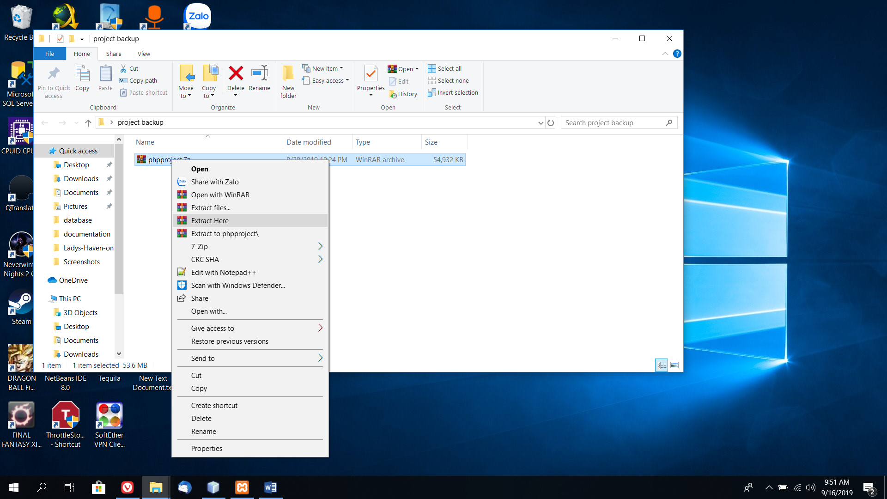

***Step 2: Configure XAMPP server***

* Download WAMP from the website: <https://www.apachefriends.org/download.html>
* Set up XAMPP on your computer.
* Right click on the icon of xamm-control.exe from the folder C:/xampp/xampp-control.exe and run as administrator
* Then click start on Apache and MySQL module.

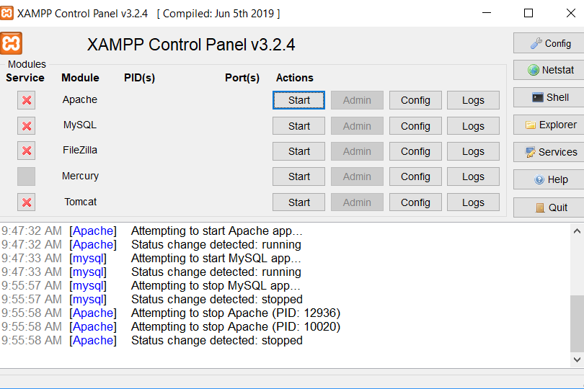

* If You are unable to start apache module, then you might have to re-configure the default port to something else as another windows programs might have already used the default 80 port. The. Therefore, to change the port of XAMPP into **8080**, please do the following steps:
* ***Step 1***

+ Open the config file by Notepad via either the following methods:

1. Open the XAMPP control panel, stop all running modules.
2. Click the “Config” button for the Apache module and select “Apache (httpd.conf)”.
3. Alternately you can open the file located in your XAMPP install folder “/apache/conf/httpd.conf” with a different text editor.
4. Find the following line around line 58 in the file. Port 80 is the default listen port for Apache.

|  |  |
| --- | --- |
| 1 | Listen 80 |

1. Change it to another port number not in use, for this example we’ll change it to port 8080.

|  |  |
| --- | --- |
| 1 | Listen 8080 |

1. Find the following line around line 225 in the same file. The ServerName variable is used to give the server a name and port to identify itself with.

|  |  |
| --- | --- |
| 1 | ServerName localhost:80 |

1. Replace it with the same port number you used in step 4.

|  |  |
| --- | --- |
| 1 | ServerName localhost:8080 |

1. Save the conf file and in the XAMPP control panel click “Config” and “Service and Port Settings”. Change the “Main Port” under the Apache tab to the port set in step 4.  
   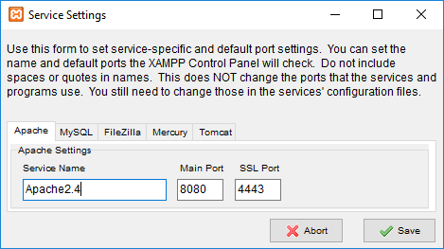
2. At this point you shouldn’t see any port errors and can start the Apache module again.
3. Open your browser and navigate to “localhost:8080” where you should now see the XAMPP dashboard or click on “Admin” in the XAMPP control panel.

***Step 2: Setup phpproject database in MySQL***

* *Start both Apache and MySQL modules in the xampp-control.*
* Open your browser of choice and type localhost or localhost:portnumber with portnuber being the port number that you changed.
* Click on phpMyAdmin on top right, and you’ll be taken right into the database window.

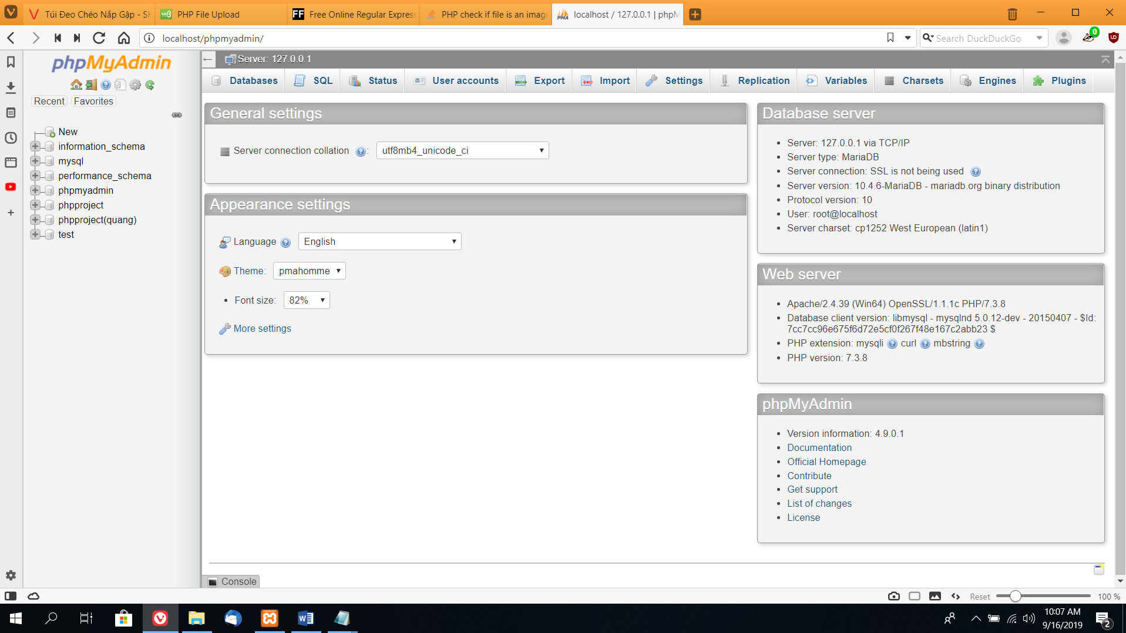

* Click on new and create a database called: phpproject.

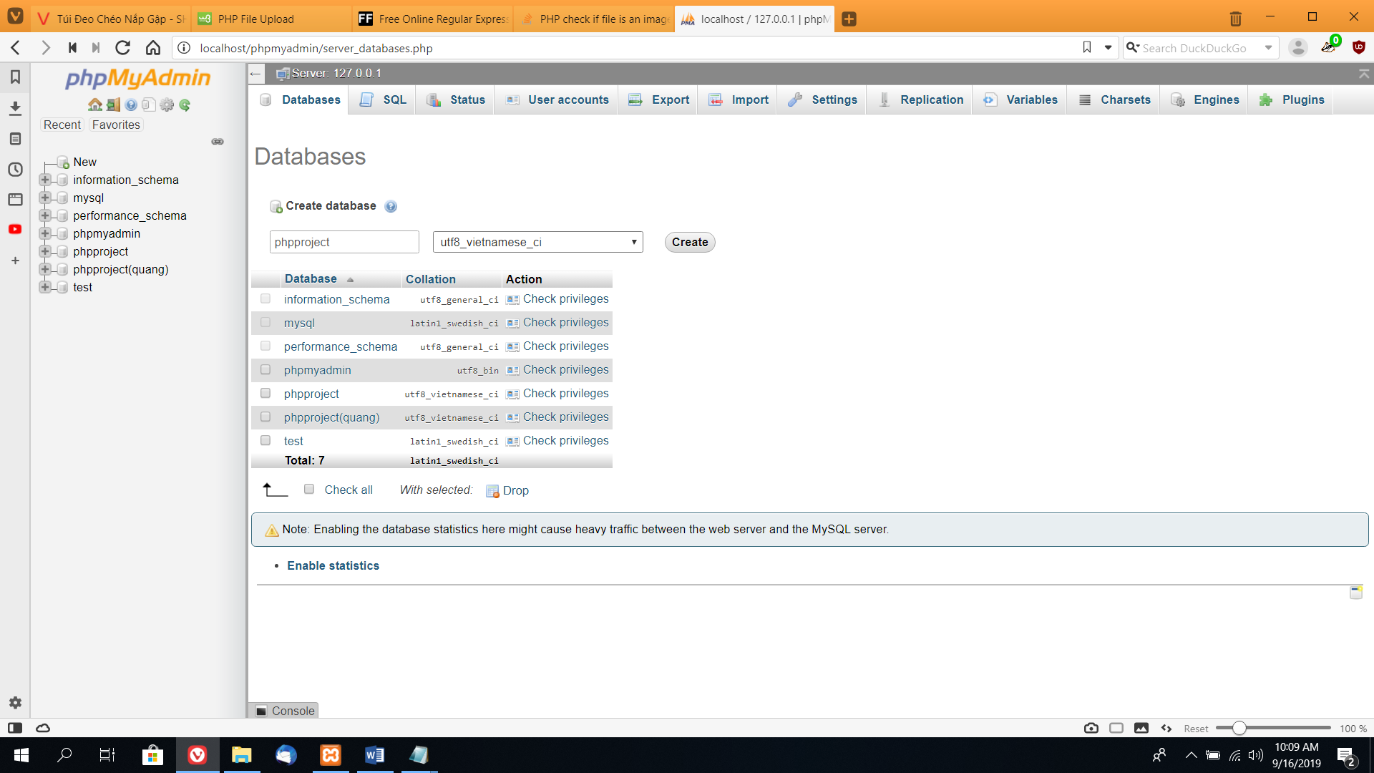

* Next step is to import the database by clicking on the database on the left tree, and then choose import from the top navigation bar.

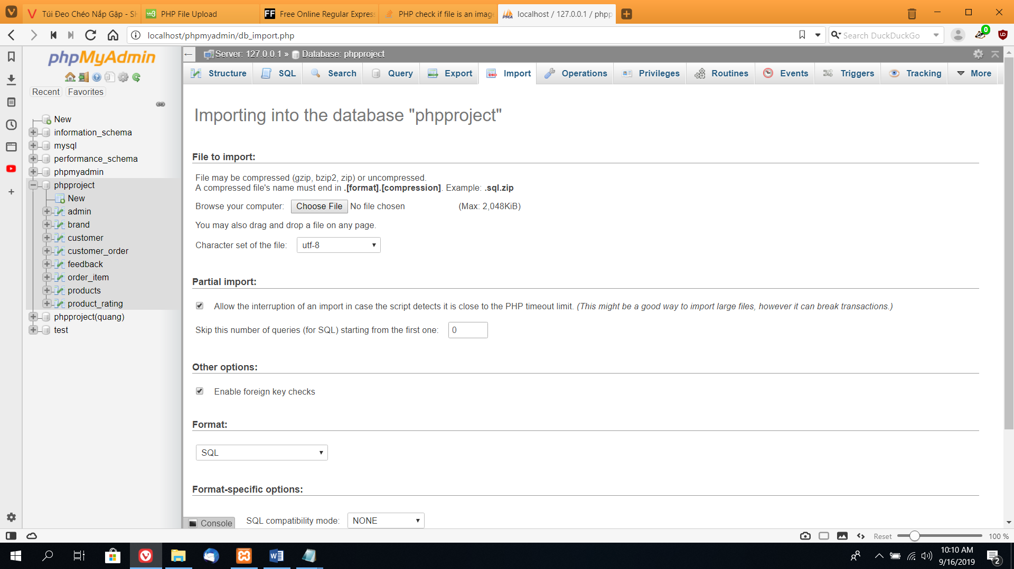

* Click on choose file and link to the database of the project file from the downloaded folder in /database/phpproject.sql

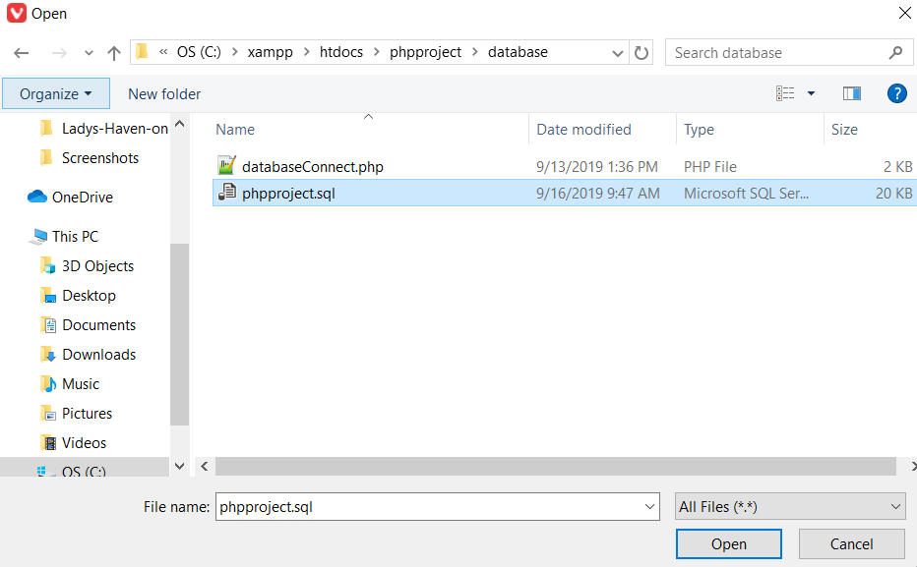

* Go back to phpproject database tab to see if all database tables have been imported properly.

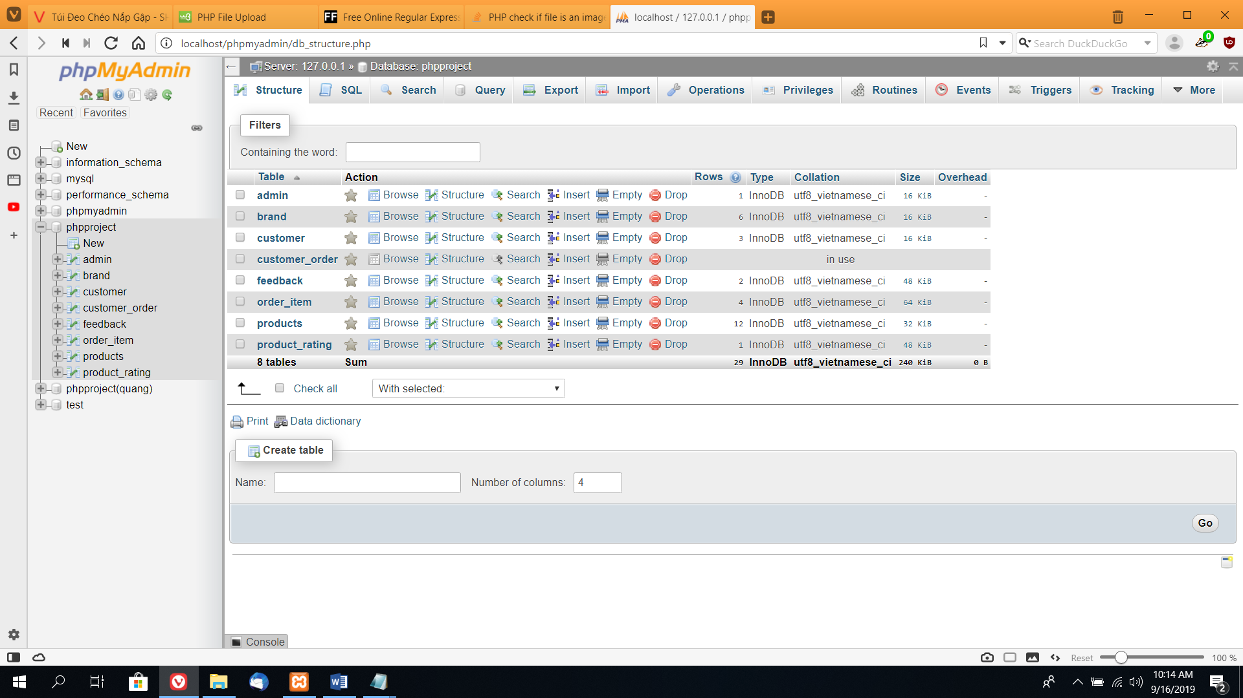

***Step 3: Open project PHP_ProjectGroup1***

* Copy the folder phpproject to the following directory: “***C:\xampp\htdocs***”.

***\* Note The directory varies depending on where you choose to install WAMP***

* Open Netbeans. If this software is not installed yet, please download it via this website: [**https://netbeans.org**](https://netbeans.org)
* If your Netbeans does not have the PHP plugin, please install it by doing the following steps:

+ Click on **Tools** in the menu bar → Choose **Plugin** (*Figure 15*)

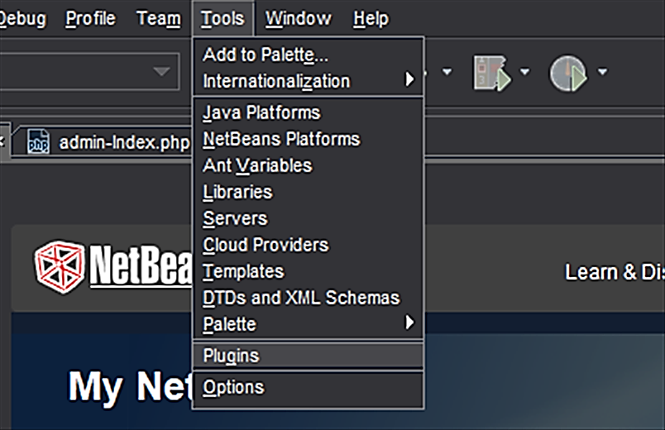

*Figure 15*

+ In the Plugin window, choose Available Plugins tab

+ Type **“PHP”** in search bar → Select following PHP plugins *(Figure 16)* → Press **Install**

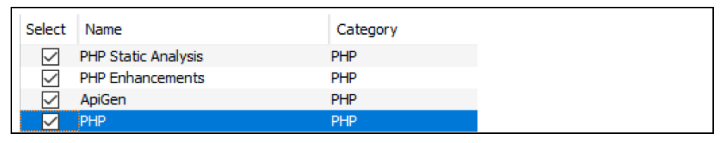

*Figure 16*

+ After the installation finishes, restart your Netbeans

* Click on **Files** in the menu bar → Choose **Open Project** *(Figure 17)*

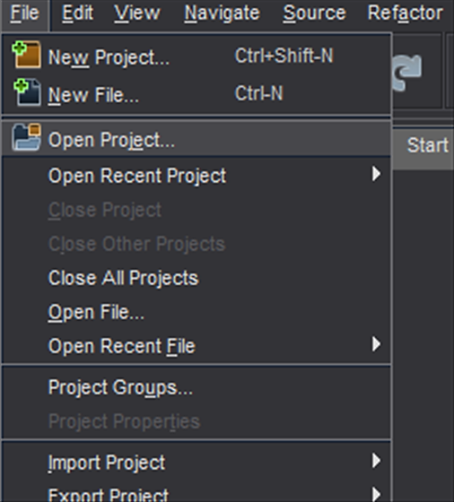

*Figure 17*

* In the Choose Project Window, Link to the project that we copy to C:/xampp/htdocs/
* Open your browser, click on the following links to access the Pizworld Inc.’s admin website and visitor website:

**+ Visitor website**: <http://localhost/phpproject/webvisitor/Main.php>

**

**+ Admin website:** http://localhost:80/phpproject/webmaster/admin_login.php

**Login by using account:**

Username: fpt

Password: 123.

